Department of Trade

- Application for micro trade registration certificate.
- Application for wholesale trade license.
- Application for retail trade license.
- Application for import house registration.

Electronic Government to Citizen Service Delivery System- Upgradation

Version 1.0

Submitted By:
NGN Technologies Ltd.
Software Requirement Specification Document

DOCUMENT RELEASE NOTICE
Document Title | : | Electronic Government to Citizen Service Delivery System- Upgradation
Release (Number) | : | 1.0
Date of Release | :
Department | : | Department of trade
Process Owner(s) | :
Author(s) / Date | : | Tshewang Tenzin
Reviewer(s) / Date | :
Approved by / Date | :

Document Acceptance
Process Owner | Designation | Agency | Sign Off
 |  | Department of trade

Table of Contents
1 Introduction 4
1.1 Purpose 4
1.2 Scope 4
1.3 Glossary 5
1.4 References 5
2 Service Specification 6
2.1 Process Flow 6
2.1.1 Application for Micro Trade Registration Certificate 6
2.1.2 Application for Wholesale Trade License 8
2.1.3 Application for Retail Trade License 10
2.2 Use Cases 12
2.2.1 Submission of Micro Trade Registration Certificate. 12
2.2.2 Approval of Micro Trade Registration Certificate. 17
2.2.3 Printing and Distributing of Micro Trade Registration Certificate. 21
2.2.4 Submission of Application for wholesale Trade License. 27
2.2.5 Verification of Wholesale Trade Registration by TRMD. 31
2.2.6 Approval of Wholesale Trade Registration by Director. 38
2.2.7 Payment, Printing and Distributing of Wholesale Trade License. 43
2.2.8 Submission of Application for Retail Trade License. 52
2.2.9 Verification of Retail Trade Registration by Data manager. 56
2.2.10 approval of Retail Trade Registration by Director. 62
2.2.11 Payment, Printing and Distributing of Retail Wholesale Trade License. 67

Introduction
The Department of Trade, Royal Government of Bhutan, hereby referred to as DOT, intends to undertake upgradation of existing system built under the G2C phase II. The existing services automation was done in order to achieve an overall improvement in service delivery and other satisfaction for the citizens.
This document describes the detailed work flow structure for three services of DOT, Application for Micro Trade Registration Certificate, Application for Wholesale Trade License, Application for Retail Trade License and detailed process flow, Actors, envisaged benefits and screen captures from the indicative prototype. This document will serve as the main contention for developing the online service delivery framework for the said agency and will form the basis on which the actual system will be designed and implemented.

1.1 Purpose
This Software Requirement Specification provides the design details for the existing system and the TO-BE system. It will explain the process for Application for Micro trade registration certificate, Application for Wholesale Trade License and Application for Retail Trade License and their delivery work-flow,features and interface of the system. This document is intended for both the stakeholders and the developers of the system.
This will also serve as a reference document for the maintenance team who will be responsible for the maintenance of the system after the final release of the product.

1.2 Scope
This document contains the complete description and design for mentioned services under DOT. This assignment is to upgrade, design, develop and deploy web-based service delivery and processes includes:
- Submission of application.
- Verification of the application.
- Approval of application.
- Payment for the application.
- Print license/certificate.

1.3 Glossary

SRS | Software Requirement Specification
G2C | Government to Citizen
ICT | Information Communication Technology
UAT | User Acceptance Test
DOT | Department of Trade
RTIO | Regional Trade and Industry Office
RD | Regional Director
CC | Community Centre
CID | Citizenship Identity Card
SCC | Security Clearance Certificate
TRMD | Trade Regulation and Monitoring division

1.4 References
- Existing Software Requirement Specifications documents
- Brainstorming session held during the System study period
- Documents supplied by G2C and MoEA during the course of requirement study

Service Specification

2.1 Process Flow

2.1.1 Application for Micro Trade Registration Certificate
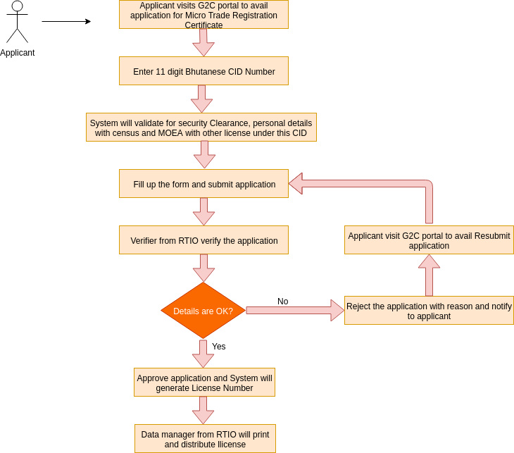

The process flow shown above depicts the Application for Micro Trade Registration Certificate. It has mainly three use-cases that includes (i) Application submission for certificate, (ii) Verification and approval of application by Data Manager, and (iii) Printing of the certificate.
Functionality wise there will be the following parts–
- Apply for Micro Trade Registration- will be made open to public where applicant/citizens can apply for micro trade license.
- Check the status of application- is exposed to the Common G2C Service Gateway. Every body can view the application status if he/she knows the application Id.
- Verification and approval of applications by Data Manager, RTIO - only accessed by Data Manager from RTIO internally after having login to the system.
- Print certificate- only accessed by Data Manager and Accounts from RTIO internally after having login to the system.

Transaction Volume
The estimated number of application for Micro Trade Registration per year will be around 700 to 800.

2.1.2 Application for Wholesale Trade License
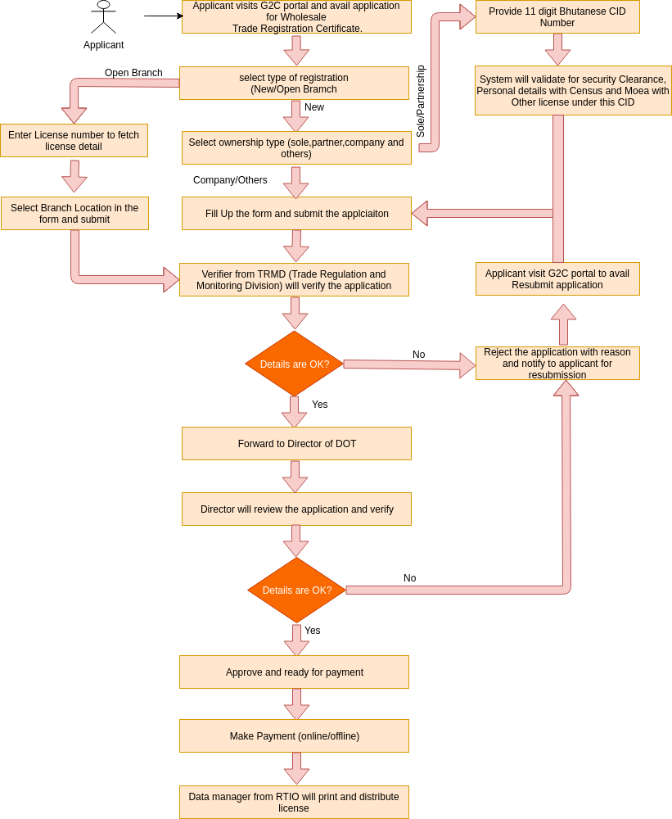

The process flow shown above depicts the Application for Wholesale Trade License. It has mainly four use-cases that includes (i) Application submission for Wholesale trade license, (ii) Verification of application by designated person from TRMD, (iii) Approving application by the Director from DOT, (iv) Printing license from RTIO by Data managers.
Functionality wise there will be the following parts–
- Apply for License- will be made open to public where applicant can apply for license without having to log-in to the system.
- Check the status of application- is exposed to the Common G2C Service Gateway without any log-in i.e. accessible to all.
- Verification of applications by designated person from TRMD- only accessed by designated person from Trade Regulation and Monitoring Division from DOT internally after having login to the system.
- Approve application by Regional Director from DOT.
- Make payment for services, can be done either form online or offline.
- Print certificate- only accessed by Data Manager from RTIO internally after having login to the system.

Transaction Volume
The estimated number of application for Wholesale Trade Registration per year will be around 50 to 100.

2.1.3 Application for Retail Trade License
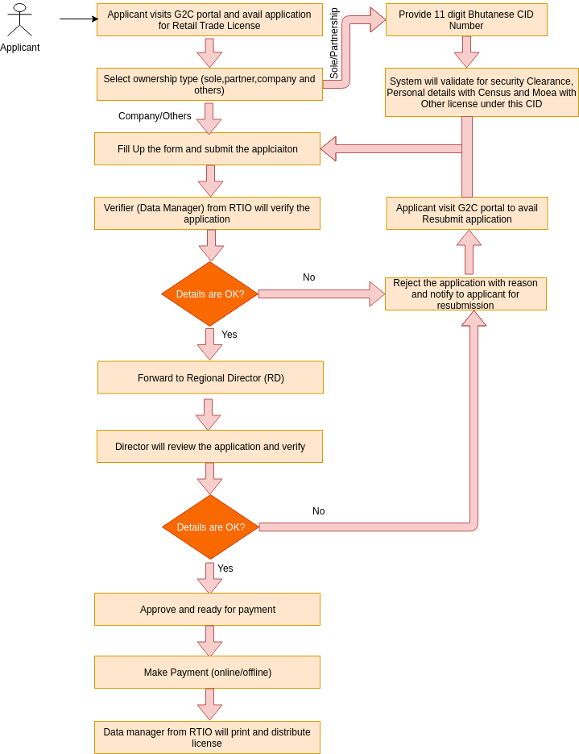

The process flow shown above depicts the Application for Retails Trade License. It has mainly four use-cases that includes (i) Application submission for Wholesale trade license, (ii) Verification of application by Data Manager from RTIO, (iii) Approving application by the Director from RTIO, (iv) Printing license by data manager from RTIO by Data managers.
Functionality wise there will be the following parts–
- Apply for License- will be made open to public where applicant can apply for license without having to log-in to the system.
- Check the status of application- is exposed to the Common G2C Service Gateway without any log-in i.e. accessible to all.
- Verification of applications by data manager from RTIO- only accessed by verifier(Data manager) from RTIO internally after having login to the system.
- Approve application by Regional Director from RTIO.
- Make payment for services, can be done either form online or offline.
- Print License - only accessed by Data Manager from RTIO internally after having login to the system.

Transaction Volume
The estimated number of application for Retail Trade Registration per year will be around 500 to 600.

2.2 Use Cases

2.2.1 Submission of Micro Trade Registration Certificate.
2.2.1.1 Description
This use case is the starting point of the application for Micro trade registration certificate. The applicant/citizen submits online application with some documents attached. The applicants can also visit nearest RTIO to apply on behalf of them, if they are not aware of the online system. If the applicant visits RTIO office, then the online form will be filled up by the responsible persons and submits the from.He/she will be redirected to the acknowledgement receipt with unique Application ID and sms notification will be send to applicant on submitting the application.

2.2.1.2 Actor(s)
Citizens of Bhutan
2.2.1.3 Detailed process flow
- Applicant can visit to G2C portal to avail application for Micro Trade Registration Certificate under Business Services.
- Click on the link called Application For Micro Trade Registration Certificate under Trade Services.
- The applicant will be redirected to the registration application form where he/she need to provide valid 11 digit Bhutanese CID number to pull personal details form census and age above 18 years, validate with security clearance,validate the CID that are not starts with 3, validate with RCSC that the applicant is not a civil servant and validate if this CID has already own other license from Trade.
- If validations are through, then the applicant will be redirected to registration page. Other wise cannot proceed further and application will stop here.
- The applicant need’s to fill up the details of application along with the required document and finally submits the form. System will forward this application to respective region where the business location is selected by applicant.
- After submission of application, applicant will get submission notification and system will redirect him/her to acknowledgement page with unique application Id.

2.2.1.4 Alternative Flows (if any)
- Applicant can visit to nearest RTIO for the Application For Micro Trade Registration Certificate if he/she is not aware or illiterate.
- Data manager form RTIO will login to the system with their user credentials and apply on behalf of applicant.
- To create application for micro trade registration on behalf of applicant, data manager need to go to the link called Micro Trade Registration under Create Application from menu bar.
- He/she will be redirected to the registration from where data manager need to provide applicant CID number to fetch personal details from census and validation with other Trade license and security clearance. Along with, he/she need to mention other field such as business details and other attachments.
- Data manager will submit the from and applicant will receive application submission notification. System will redirect him/her to acknowledgement page with unique application Id.

2.2.1.5 Special requirement (if any)
NA.

2.2.1.6 Pre Conditions
Following are the pre- conditions to use the service –
- Scanning facility should be there at RTIO scan the required documents.
- Applicant should know their CID number.
- Applicant should have all required document if he/she applies by them self.

2.2.1.7 Post Conditions
Data manager’s task list is populated with the application submitted by applicants.

2.2.1.8 Sample user interface
- Open www.citizenservices.gov.bt and click on Business Services as shown below.
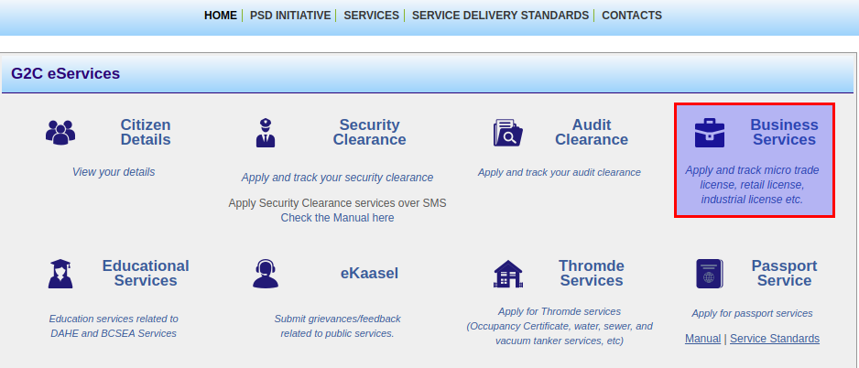

- Select application for Micro Trade Registration under Trade Services.
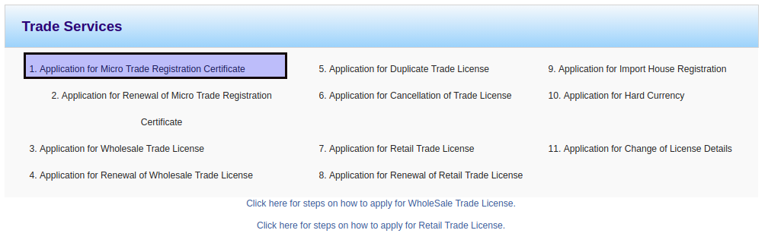

- The applicant will be redirected to the micro trade registration from as shown below. 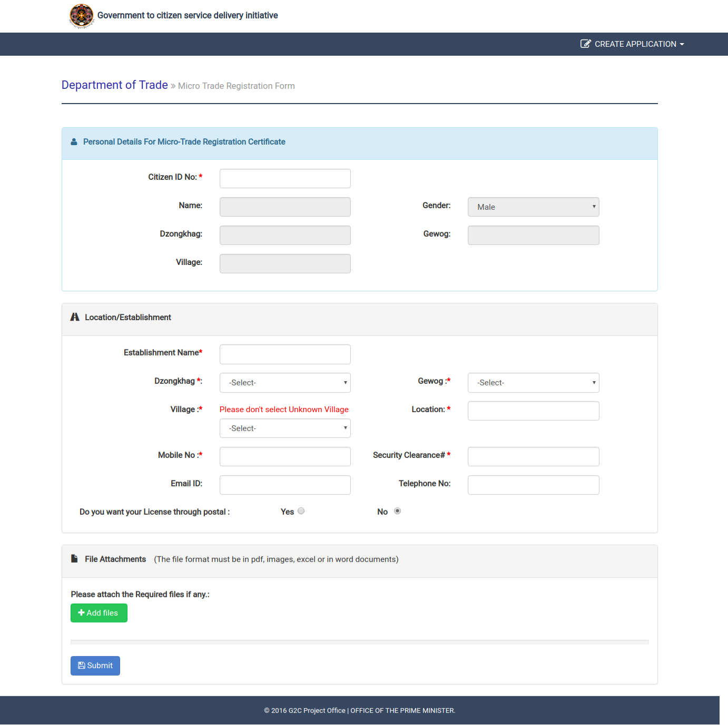

- System will fetch personal detail from census database on entering the valid CID number. Then the applicant need to provide the business details and others with required attachments. Then he/she will submit the form and system will notified with submission notification and redirected to following acknowledgement page.

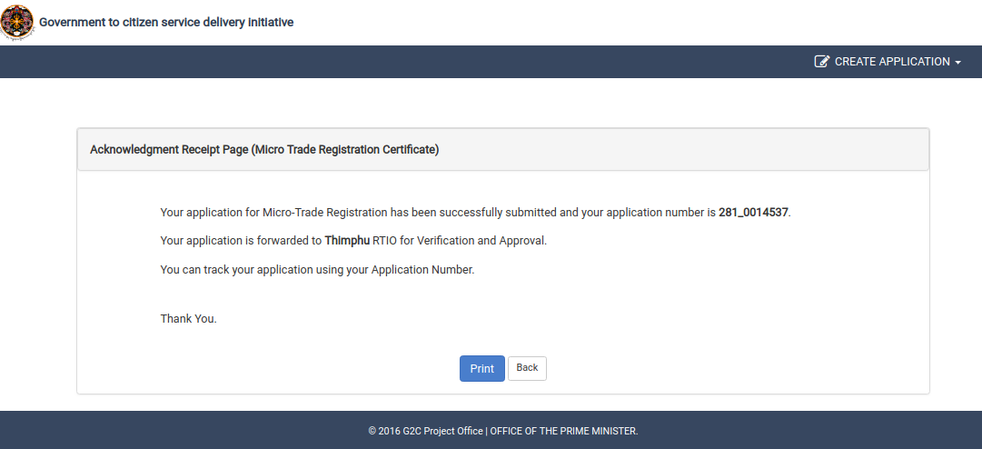

2.2.2 Approval of Micro Trade Registration Certificate.
2.2.2.1 Description
This use case will describe how the application for Micro trade registration certificate is being verified and approve by data managers from RTIO. The data manager form RTIO need to log in to the system and needs to pick application for micro trade from group task. He/she can also release application back to group task so that the application will be visible to other data manager from same region, if he/she cannot take action. Clicking on application id from my task list, application will open and all details will be displayed for verification and approval. Now he/she may approve or reject the application according to the application requirement.
2.2.2.2 Actor(s)
Data manager (Verifiers) from RTIO.
2.2.2.3 Detailed process flow
- Data manager can visit to G2C portal and login with his/her valid user credentials.
- Task list will be displayed and Application For Micro Trade Registration Certificate will be listed in either group task list if that application is not yet claimed by any one with same role and region or in my task list if that application was already claimed and not taken any action.
- If application is in group task list, then data manager need to claim that application to assign in my task list to take action. Then he/she needs to open the application.
- After reviewing the application details, he/she need to take action(approve/reject) or assign back to group task list if he/she can’t take any action.
- Data manager will either approves or rejects the application after verification of application details. If application is rejected, then applicant will receive notification with reason for rejecting and notification for payment information if the application is approved.
- If Data manager rejected the application, then applicant may resubmit the application with the changes according to the remarks or reason mention by DM.
- The data manager will be redirected to the acknowledgement page for respective actions.

2.2.2.4 Alternative Flows (if any)
NA.

2.2.2.5 Special requirement (if any)
NA.

2.2.2.6 Pre Conditions
Following are the pre- conditions to use the service –
- Internet access at RTIO.
- Should have valid login credentials.

2.2.2.7 Post Conditions
Applicant will receive sms notification for taking any action by data manager.

2.2.1.8 Sample user interface
- Open www.citizenservices.gov.bt and click on log in as shown below and provide valid user credentials(username and password).

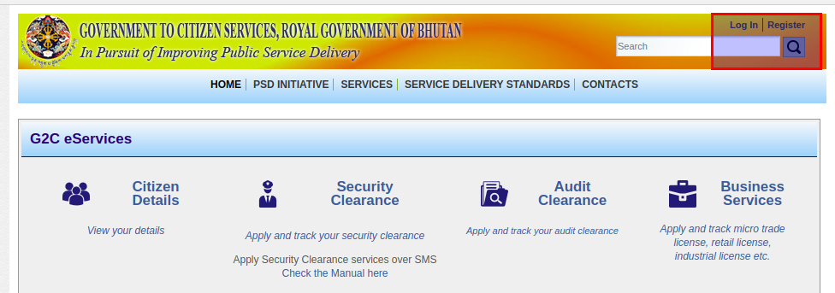

- He/she will be redirected to the dash board containing application list according to the role as shown below.
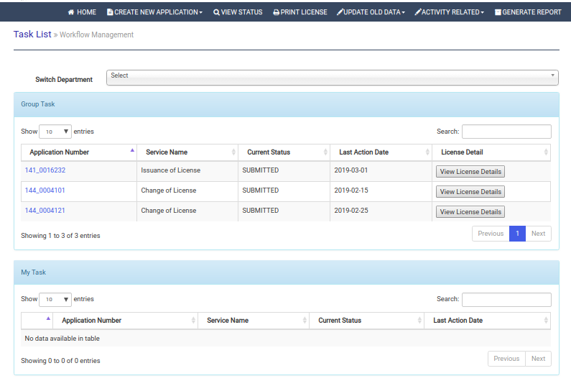

- Click on application number in group task list to claim to my task list. From my task list, again click on application number to open application. Click on red cross button form my task list to release application back to group task.
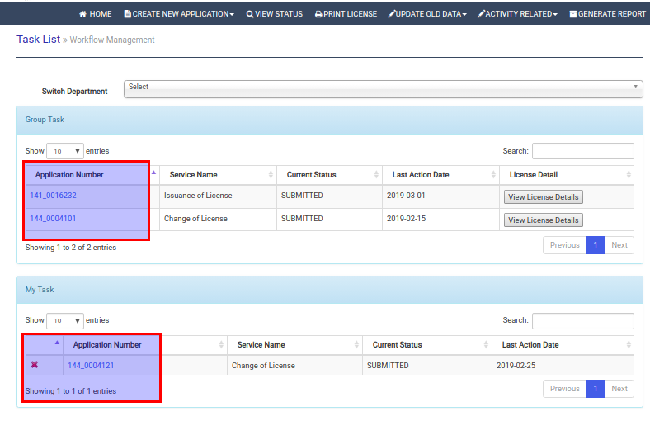

- Review and verify application details.

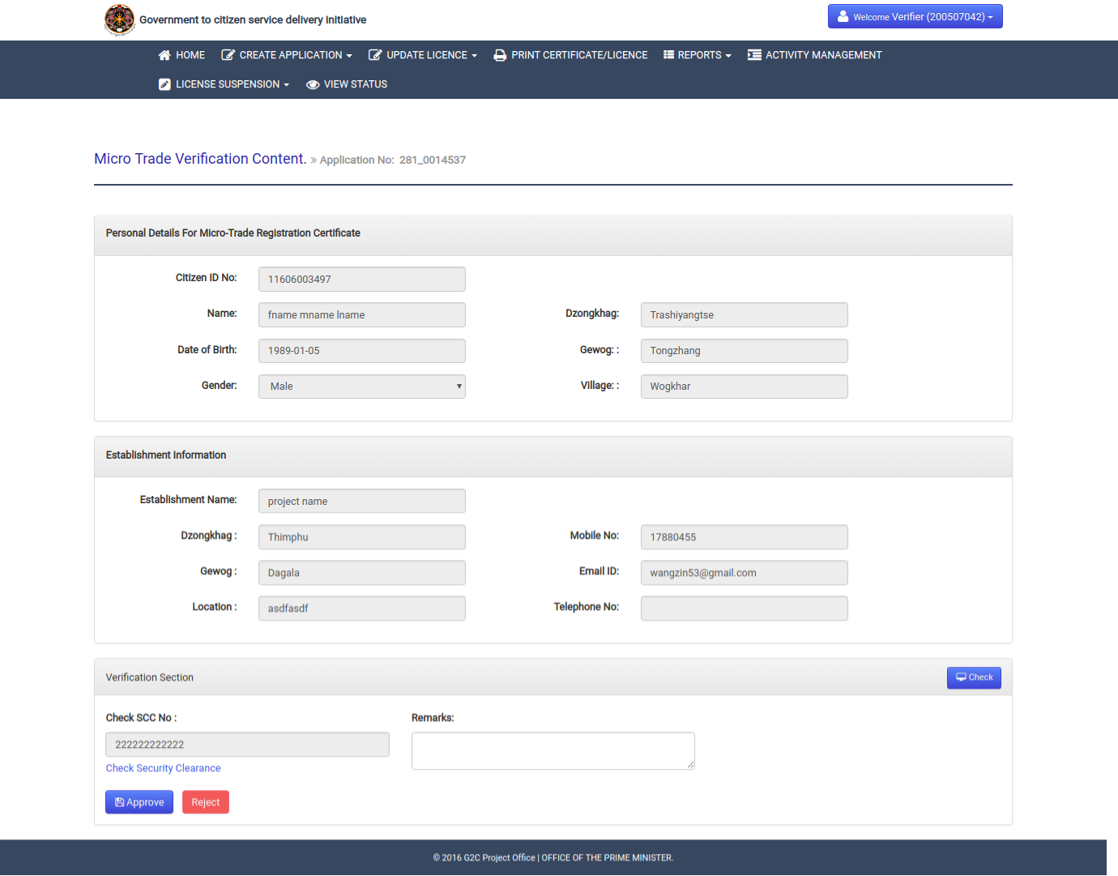

- After verification of the application details, he/she may need to take any of the action approve or reject. He/she needs to provide reason if application need to reject. Then, he/she will be redirected to the acknowledgement page with the sms notification to applicant.
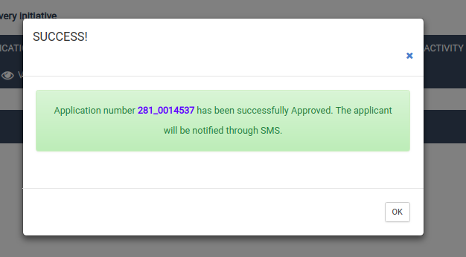

2.2.3 Printing and Distributing of Micro Trade Registration Certificate.
2.2.3.1 Description
This use case will describe how the Micro trade registration certificate will be printed and distributed to applicant from RTIO. The data manager form RTIO need to log in to the system to print the certificate. He/she needs to click on the link called print certificate/license from menu list and will be redirected to select update payment or print certificate with the regions and services. After selecting the print certificate tab with Micro trade License as service form service list and the particular region from region list, he will get the list of micro trade certificate to print. Then he/she can print and distribute to applicant.
2.2.3.2 Actor(s)
Data manager (Verifiers) from RTIO and applicant.
2.2.3.3 Detailed process flow
- Data manager can visit to G2C portal and login with his/her valid user credentials.
- Need to go with the link called print certificate/license from menu bar.
- Need to select print certificate tab from two tabs (Update payment and print certificate).
- Need to select the service as micro trade license from service list and region where the applicant belongs to from region list.
- On clicking on get list, the list of application for micro trade certificate which are approved will be listed and need to identify the application to print.
- Now the data manager will print the certificate and distributed to applicant.

2.2.3.4 Alternative Flows (if any)
NA.

2.2.3.5 Special requirement (if any)
NA.

2.2.3.6 Pre Conditions
Following are the pre- conditions to use the service –
- Internet access at RTIO.
- Data manager should have valid login credentials.

2.2.3.7 Post Conditions
NA.

2.2.3.8 Sample user interface
- Open www.citizenservices.gov.bt and click on log in as shown below and provide valid user credentials(username and password).

- He/she will be redirected to the dash board containing application list according to the role as shown below.

- Click on the link called print certificate from menu bar.
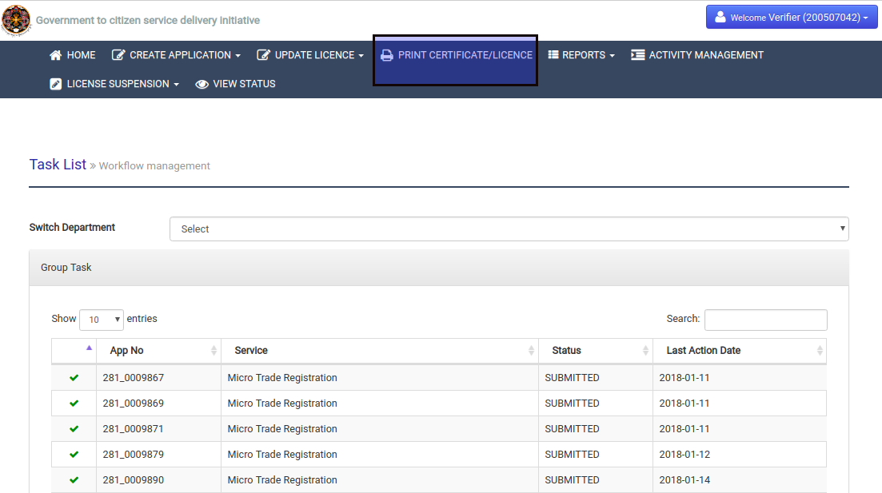

- Data manager will be redirected to the following page where he/she need to select the print certificate tab, service as micro trade and region where applicant belongs to.
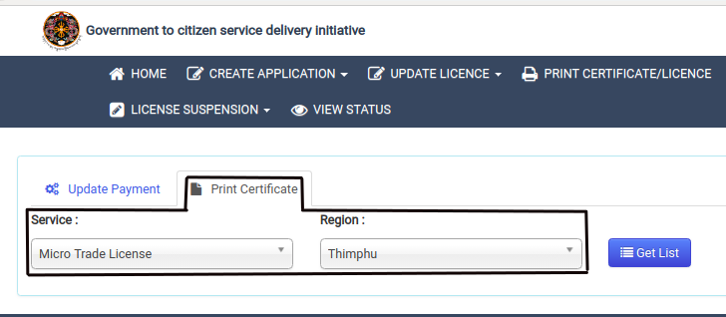

- After clicking on the get list button, all the approved micro trade registration certificate will be displayed as shown below.
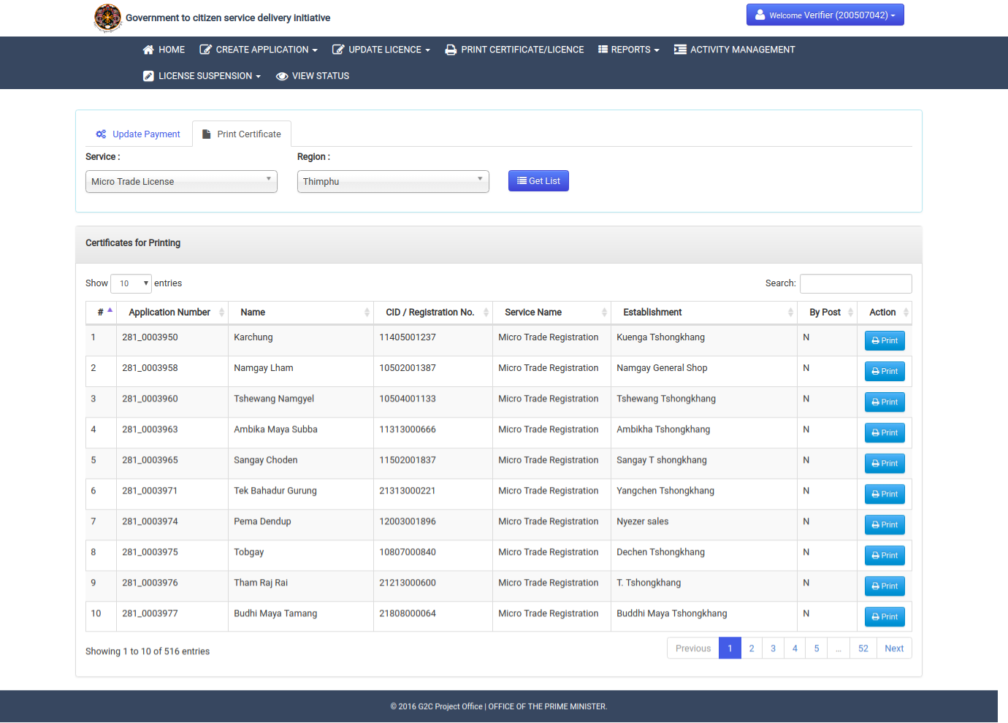

- Now data manager will click on print button to print certificate and distribute to applicant.Following image represent the license printed content from the system.
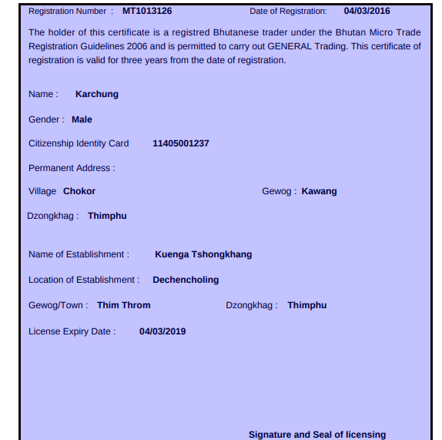

2.2.4 Submission of Application for wholesale Trade License.
2.2.4.1 Description
This use case is the starting point of the application for wholesale trade license. The applicant submits online application with some documents attached. The applicants can also visit nearest RTIO to apply on behalf of them, if they are not aware of the online system. If the applicant visits RTIO office, then the online form will be filled up by the responsible persons and submits the from.He/she will be redirected to the acknowledgement receipt with unique Application ID and sms notification will be send to applicant on submitting the application.

2.2.4.2 Actor(s)
Citizens of Bhutan
2.2.4.3 Detailed process flow
- Applicant can visit to G2C portal to avail application for Wholesale Trade License under Business Services.
- Click on the link called Application For Wholesale Trade License under Trade Services.
- The applicant will be redirected to the registration application form.
- The applicant needs to select the ownership type for the license from the broad category of sole proprietorship, partnership, company or others.
- For sole and partnership, applicant need to provide CID number where the system will validate with census and fetch the personal details. For company and others, the applicant need to mention all the license owner name such and company details for company and other names for other ownership type.
- Applicant need to fill up all necessary fields in the form and finally need to attach documents to support the information provided in the form and finally need to accept the undertaking for this application.
- After submitting the form, applicant will receive submission notification and he/she will be redirected to acknowledgement page.

2.2.4.4 Alternative Flows (if any)
- Applicant can visit to nearest RTIO for the Application For Wholesale Trade License if he/she is not aware or illiterate.
- Data manager form RTIO will login to the system with their user credentials and apply on behalf of applicant.
- To create application for wholesale trade license on behalf of applicant, data manager need to go to the link called Wholesale Trade Registration under Create Application from menu bar.
- He/she will be redirected to the registration from where data manager need to provide applicant CID number to fetch personal details from census. Along with, he/she need to select ownership type, mention other field such as business details and other attachments.
- Data manager will submit the from and applicant will receive application submission notification. System will redirect him/her to acknowledgement page.

2.2.4.5 Special requirement (if any)
NA.

2.2.4.6 Pre Conditions
Following are the pre- conditions to use the service –
- Scanning facility should be there at RTIO to scan the required documents.
- Applicant should know their CID number.
- Applicant should have all required document if he/she applies by them self.

2.2.4.7 Post Conditions
Data manager’s task list is populated with the application submitted by applicants.

2.2.4.8 Sample user interface
- Open www.citizenservices.gov.bt and click on Business Services as shown below.

- Select application for Wholesale Trade License under Trade Services.
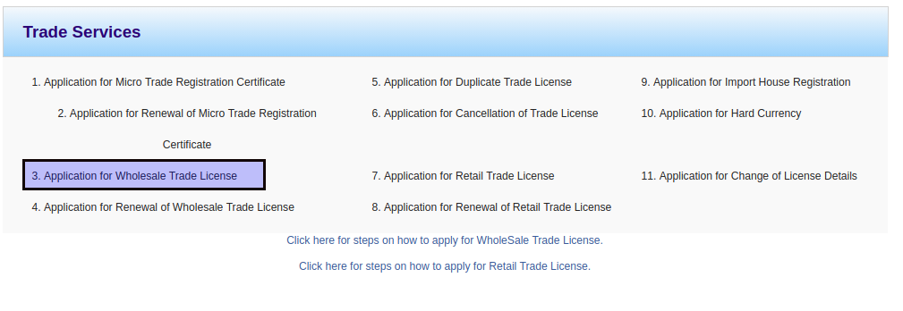

- The applicant will be redirected to the wholesale trade registration from as shown below.
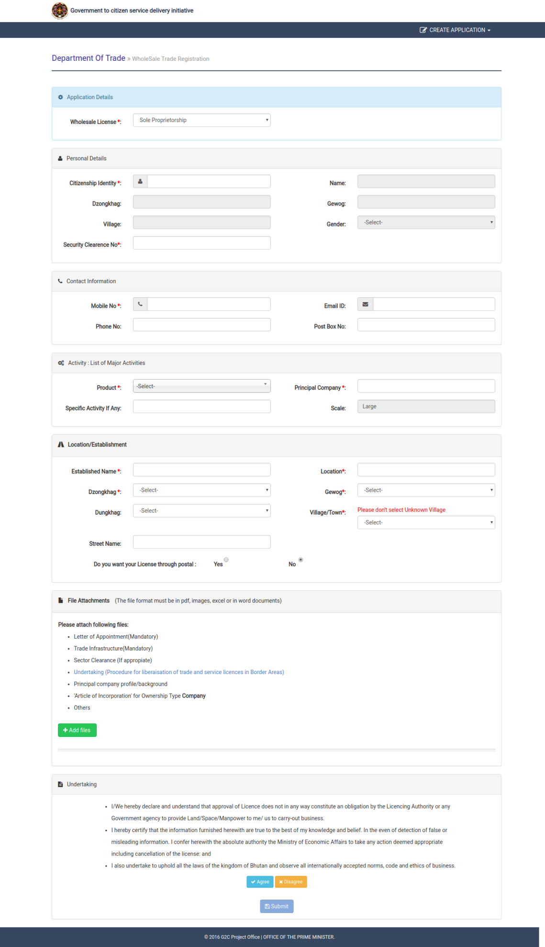

- System will fetch personal detail from census database on entering the valid CID number. Then the applicant need to provide the business details and others with required attachments. Then he/she will submit the form and system will notified with submission notification and redirected to following acknowledgement page.

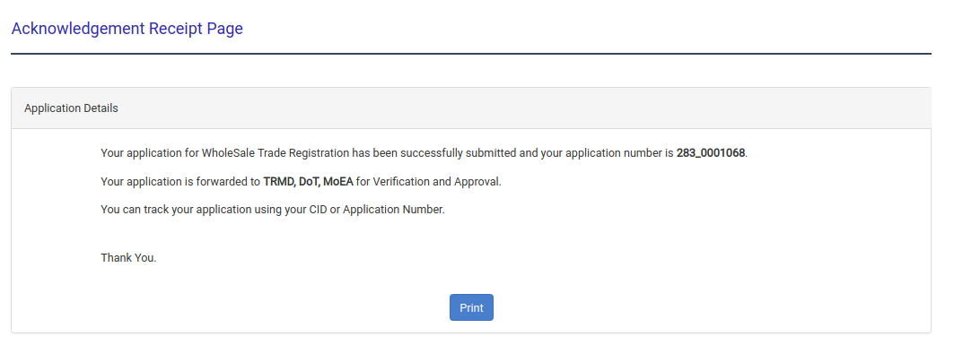

2.2.5 Verification of Wholesale Trade Registration by TRMD.
2.2.5.1 Description
This use case will describe how the application for Wholesale trade registration is being verified by Trade and Regulation Monitoring Division (TRMD). The TRMD need to log in to the system and needs to pick application for wholesale trade from group task to proceed with verification. He/she can also release application back to group task so that the application will be visible to other with same role, if he/she cannot take action. Clicking on application id from my task list, application will open and all details will be displayed for verification. Now he/she may verify or reject the application according to the application requirement.
2.2.5.2 Actor(s)
TRMD from DOT.
2.2.5.3 Detailed process flow
- TRMD can visit to G2C portal and login with his/her valid user credentials.
- Task list will be displayed and Application For Wholesale Trade Registration will be listed in either group task list if that application is not yet claimed by any one with same role or in my task list if that application was already claimed and not taken any action.
- If application is in group task list, then he/she needs to claim that application to my task list and take action. Then he/she needs to open the application.
- After reviewing the application details, he/she need to take action(verify/reject) or assign back to group task list if he/she can’t take any action.
- TRMD will either verify or rejects the application. If application is rejected, then applicant will receive notification with reason for rejecting and if the application is verified then the same application will be reached to Director’s task list of DOT.
- TRMD will be redirected to the acknowledgement page for respective actions.

2.2.5.4 Alternative Flows (if any)
NA.

2.2.5.5 Special requirement (if any)
NA.

2.2.5.6 Pre Conditions
Following are the pre- conditions to use the service –
- Internet access at RTIO.
- Should have valid login credentials.

2.2.5.7 Post Conditions
Applicant will receive sms notification for taking any action by TRMD and Director’s task list will be populated with verified applications.

2.2.5.8 Sample user interface
- Open www.citizenservices.gov.bt and click on log in as shown below and provide valid user credentials(username and password).

- He/she will be redirected to the dash board containing application list according to the role as shown below.
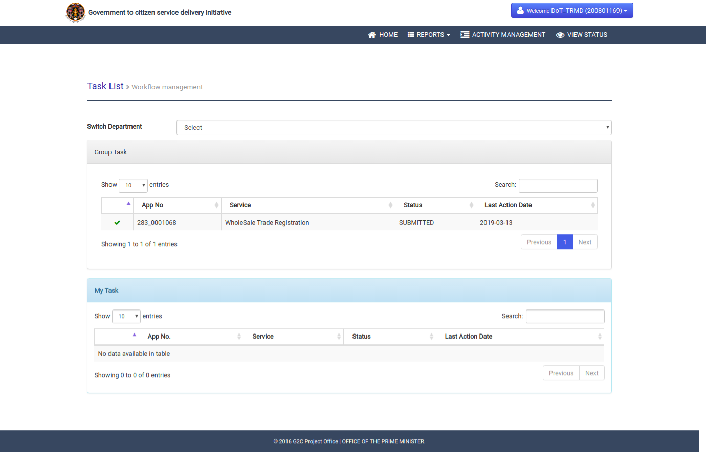

- Click on application number in group task list to claim to my task list. From my task list, again click on application number to open application. Click on red cross button form my task list to release application back to group task.

- Review and verify application details.

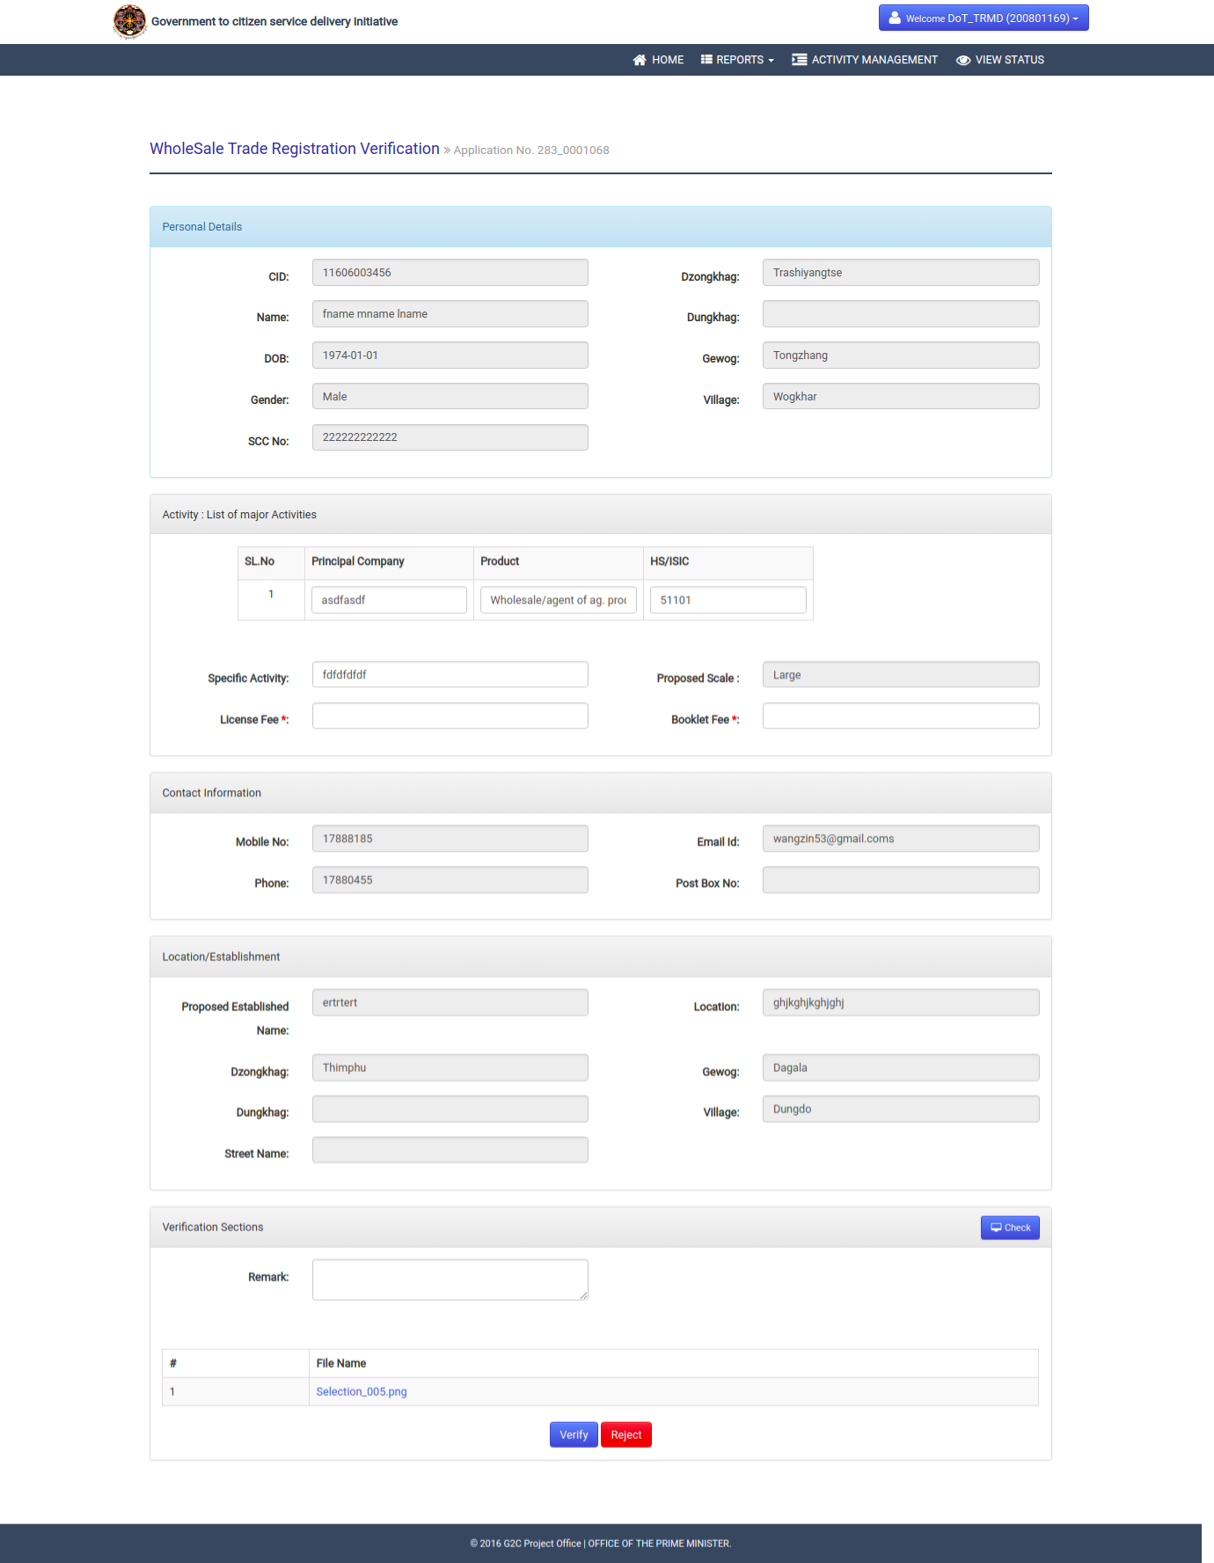

- After verification of the application details, he/she may need to take any of the action verify or reject. He/she needs to provide reason if application need to reject and need to mention fees details for service if verify. Then, he/she will be redirected to the acknowledgement page with the sms notification to applicant.
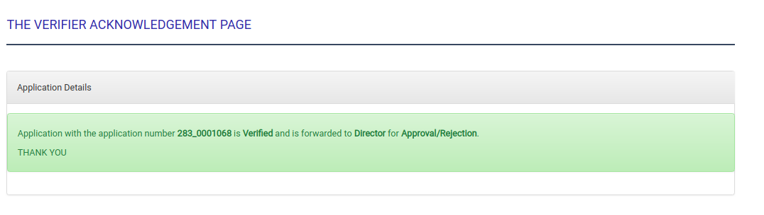

2.2.6 Approval of Wholesale Trade Registration by Director.
2.2.6.1 Description
This use case will describe how the application for Wholesale trade registration is being approved by director from DOT. The director need to log in to the system and needs to pick application for wholesale trade from group task to proceed with verification. He/she can also release application back to group task so that the application will be visible to other with same role, if he/she cannot take action. Clicking on application id from my task list, application will open and all details will be displayed for verification. Now he/she may verify or reject the application according to the application requirement.
2.2.6.2 Actor(s)
Director from DOT.
2.2.6.3 Detailed process flow
- Director can visit to G2C portal and login with his/her valid user credentials.
- Task list will be displayed and Application For Wholesale Trade Registration will be listed in either group task list if that application is not yet claimed by any one with same role or in my task list if that application was already claimed and not taken any action.
- If application is in group task list, then he/she needs to claim that application to my task list and take action. Then he/she needs to open the application.
- After reviewing the application details, he/she need to take action(approve/reject) or assign back to group task list if he/she can’t take any action.
- Director will either approve or rejects the application. If application is rejected, then applicant will receive notification with reason for rejecting and if the application is approved then the same application will be reached to print list.
- Director will be redirected to the acknowledgement page for respective actions.

2.2.6.4 Alternative Flows (if any)
NA.

2.2.6.5 Special requirement (if any)
NA.

2.2.6.6 Pre Conditions
Following are the pre- conditions to use the service –
- Internet access at RTIO.
- Should have valid login credentials.

2.2.6.7 Post Conditions
Applicant will receive sms notification for taking any action by Director.

2.2.6.8 Sample user interface
- Open www.citizenservices.gov.bt and click on log in as shown below and provide valid user credentials(username and password).

- He/she will be redirected to the dash board containing application list according to the role as shown below.

- Click on application number in group task list to claim to my task list. From my task list, again click on application number to open application. Click on red cross button form my task list to release application back to group task.

- Review and verify application details.

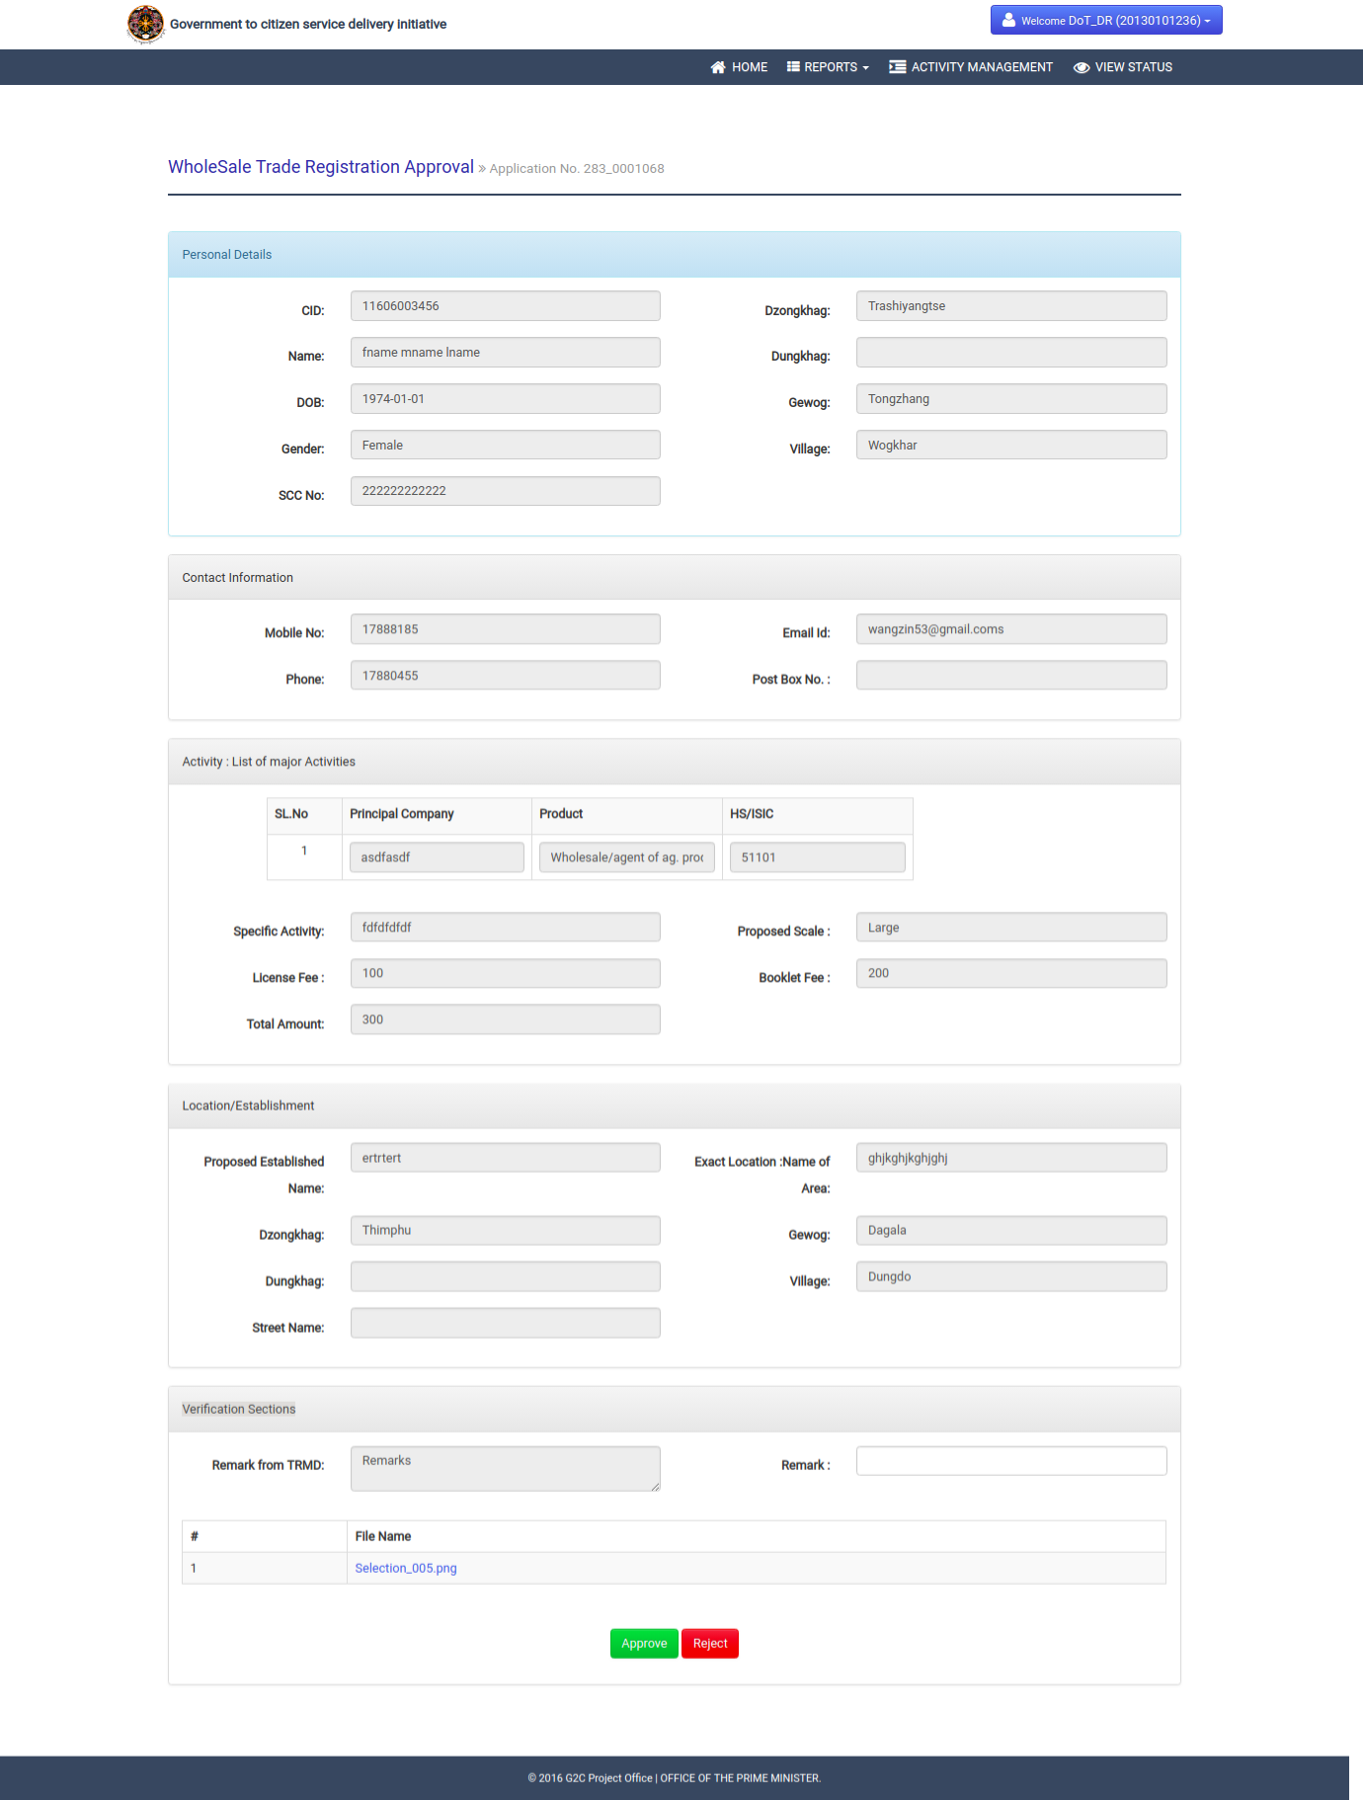

- After verification of the application details, he/she may need to take any of the action approve or reject. He/she needs to provide reason if application need to reject. Then, he/she will be redirected to the respective acknowledgement page for taking action and sms notification will be send to applicant.
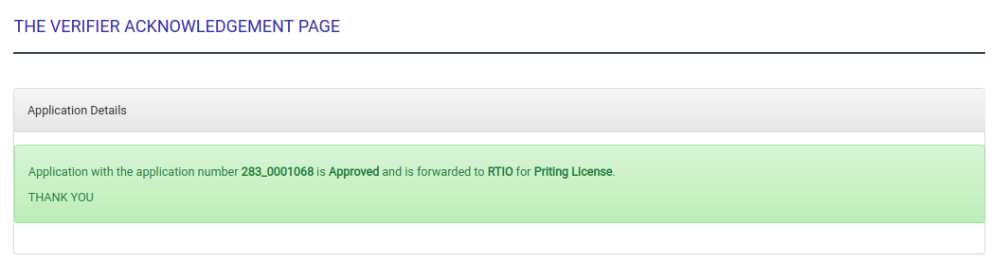

2.2.7 Payment, Printing and Distributing of Wholesale Trade License.
2.2.7.1 Description
This use case will describe how the wholesale trade registration will be printed and distributed to applicant from RTIO after making payment for availing service. The data manager form RTIO need to log in to the system to update payment and print the certificate. Applicant can make payment in two ways, either pay online or pay at rtio(offline). If applicant update payment online, then he/she need to visit G2C portal for payment with application id or same link can be open form sms notification. If applicant make payment at RTIO, then data manager will update the payment details in the system. Data manager need to visit the link called Print certificate from menu and select update payment tab, select service name and region where the application belongs to and then need to provide payment details after opening the form. After updating the payment, application will be there in print list and data manager again need to visit same link from menu and select print certificate tab and print license.
2.2.7.2 Actor(s)
Data manager (Verifiers) from RTIO and applicant.
2.2.7.3 Detailed process flow
- Data manager can visit to G2C portal and login with his/her valid user credentials.
- Need to go with the link called print certificate/license from menu bar.
- To update the payment at RTIO, data manager needs to select the tab called Update payment, select the service as wholesale trade license and respective region form drop down list. And click on get details button.
- The list of approved application for wholesale trade registration will be displayed. He/she needs to select the application and click on update payment button to reach payment form.
- Provide payment details and press update button to record the payment details.
- The application status will be updated to approved will be there in print list.
- Data manager needs to click on same link called print certificate from menu and select print certificate tab, service as wholesale trade and region to list the application list to print.
- Now he/she may select application to print and distribute to applicant.

2.2.7.4 Alternative Flows (if any)
- The applicant can update payment online. To do that, applicant need to visit his sms to reach payment link directly to update payment.
- Applicant can also visit to G2C portal, and search for G2C payment link to update if he/she knows the application number.
- After providing valid and approved wholesale trade registration number, payment details will be displayed and need to clink on pay now button to update or make payment.
- The applicant will get interface to select available banks and OTP will send to registered mobile number for validation.
- Then the applicant will get payment receipt number and application status will be updated to print.

2.2.7.5 Special requirement (if any)
NA.

2.2.7.6 Pre Conditions
Following are the pre- conditions to use the service –
- Internet access at RTIO.
- Data manager should have valid login credentials.

2.2.7.7 Post Conditions
NA.

2.2.7.8 Sample user interface
- Open www.citizenservices.gov.bt and click on log in as shown below and provide valid user credentials(username and password).

- He/she will be redirected to the dash board containing application list according to the role as shown below.

- Click on the link called print certificate from menu bar.

- Data manager will be redirected to the following page where he/she need to select the update payment tab, service as wholesale License and region where applicant belongs to update payment.
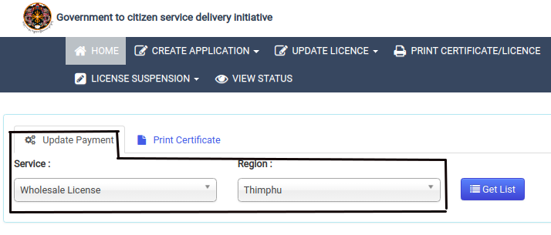

- After clicking on the get list button, all the approved micro trade registration certificate will be displayed as shown below.

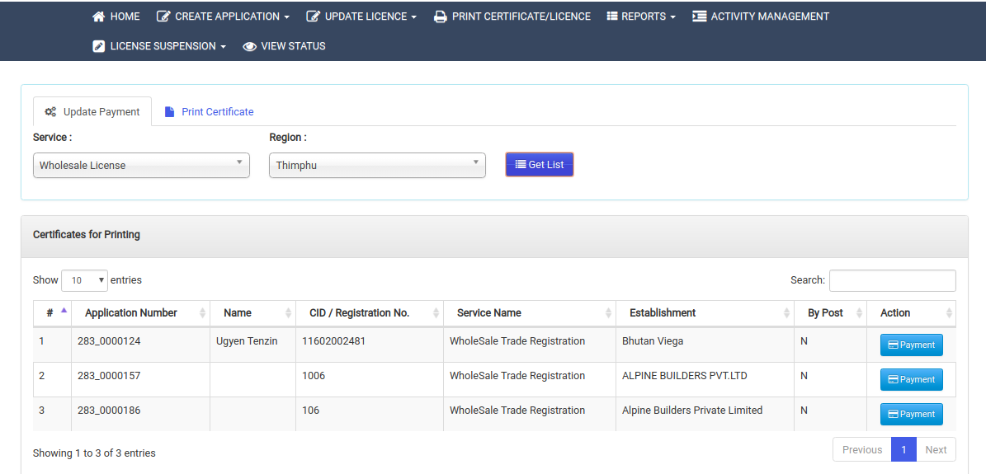

- After selecting the application, click on payment button to display form for payment update as shown below.

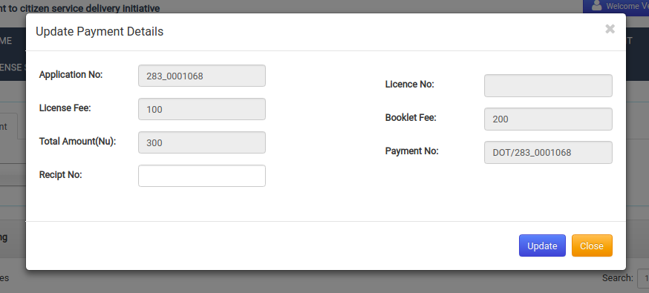

- After updating the payment, the application will be there in the print list and need to click on same link called print certificate from menu bar.

- Data manager will be redirected to the following page where he/she need to select the print certificate tab, service as wholesale trade and region where applicant belongs to.

- After clicking on the get list button, all the approved micro trade registration certificate will be displayed as shown below.

- Now data manager will click on print button to print certificate and distribute to applicant.Following image represent the license printed content from the system.
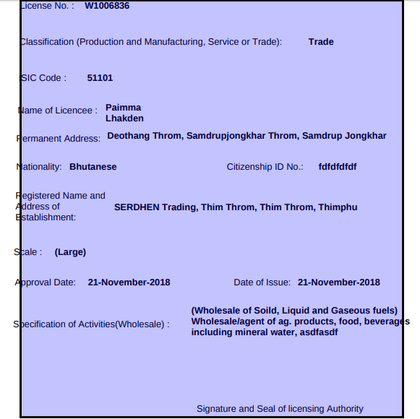

2.2.8 Submission of Application for Retail Trade License.
2.2.8.1 Description
This use case is the starting point of the application for Retail trade license. The applicant submits online application with some documents attached. The applicants can also visit nearest RTIO to apply on behalf of them, if they are not aware of the online system. If the applicant visits RTIO office, then the online form will be filled up by the responsible persons and submits the from.He/she will be redirected to the acknowledgement receipt with unique Application ID and sms notification will be send to applicant on submitting the application.

2.2.8.2 Actor(s)
Citizens of Bhutan
2.2.8.3 Detailed process flow
- Applicant can visit to G2C portal to avail application for Retail Trade License under Business Services.
- Click on the link called Application For Retail Trade License under Trade Services.
- The applicant will be redirected to the page where he/she need to select ownership type of license. The broad category of ownership type can be sole proprietorship, partnership, company and others.
- For sole and partnership, applicant need to provide CID number where the system will validate with census and fetch the personal details. For company applicant need to provide company registration number and for others, the applicant need to mention agency name.
- The applicant will be reach to registration form to fill up activity details and others.
- After filling up the necessary fields, he/she will submit the form and will be redirected to the acknowledgement page with application submission notification.

2.2.8.4 Alternative Flows (if any)
- Applicant can visit to nearest RTIO for the Application For Retail Trade License if he/she is not aware or illiterate.
- Data manager form RTIO will login to the system with their user credentials and apply on behalf of applicant.
- To create application for retail trade license on behalf of applicant, data manager need to go to the link called Retail Trade Registration under Create Application from menu bar.
- He/she will be redirected to the registration from where data manager need to provide applicant CID number to fetch personal details from census. Along with, he/she need to select ownership type, mention other field such as business details and other attachments.
- Data manager will submit the from and applicant will receive application submission notification. System will redirect him/her to acknowledgement page.

2.2.8.5 Special requirement (if any)
NA.

2.2.8.6 Pre Conditions
Following are the pre- conditions to use the service –
- Scanning facility should be there at RTIO to scan the required documents.
- Applicant should know their CID number.
- Applicant should have all required document if he/she applies by them self.

2.2.8.7 Post Conditions
Data manager’s task list is populated with the application submitted by applicants.

2.2.8.8 Sample user interface
- Open www.citizenservices.gov.bt and click on Business Services as shown below.

- Select application for Retail Trade License under Trade Services.
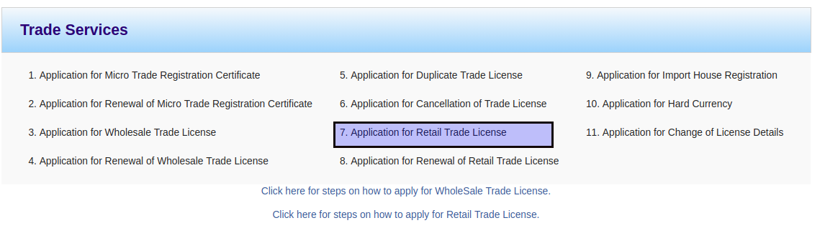

- The applicant will be redirected to ownership type.
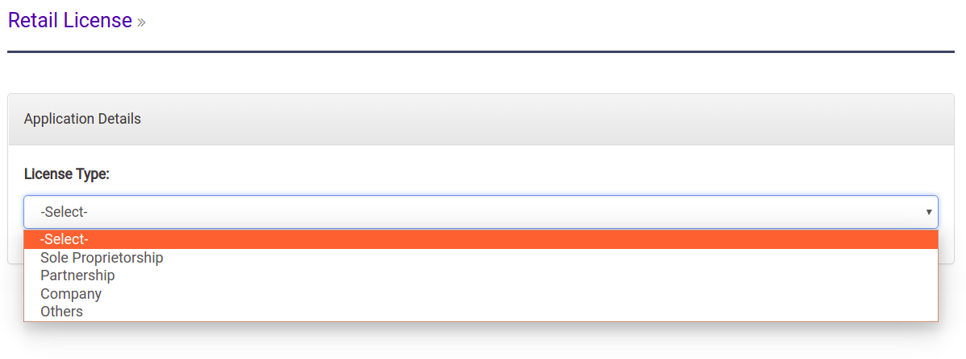

- After selecting ownership type and inputting respective fields, the applicant will redirected the retail registration form as shown below.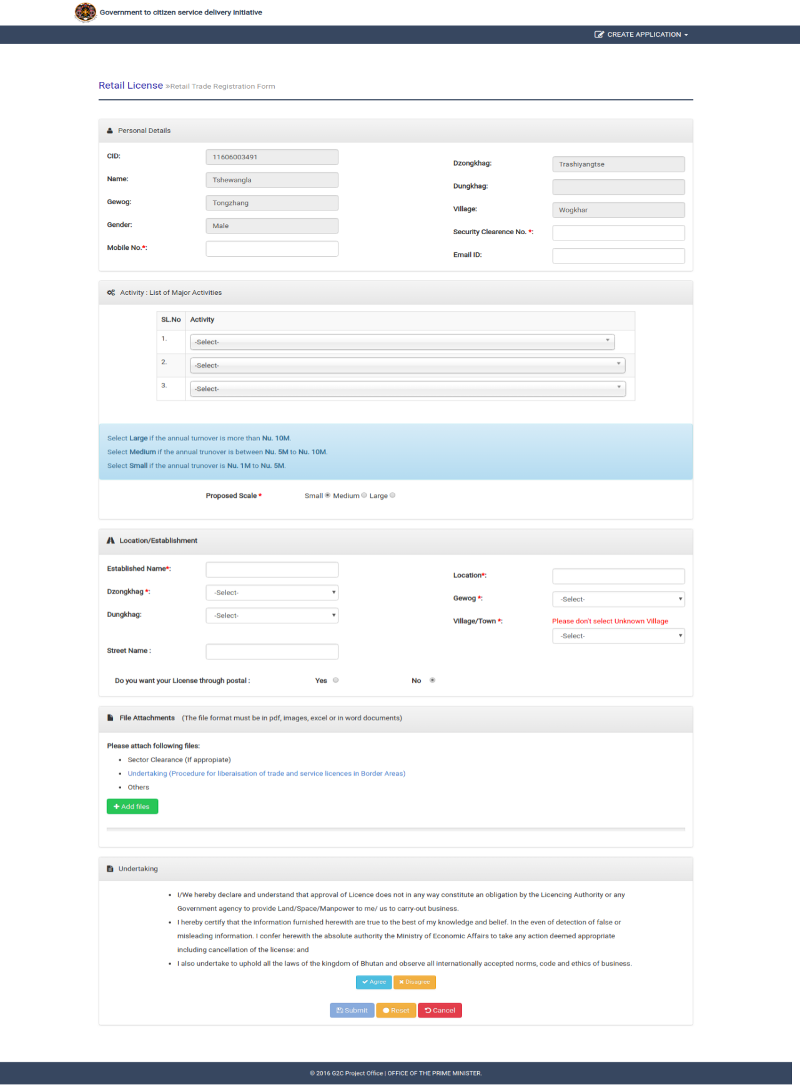

- After filling up the form with required attachments, the system will show acknowledgement page as represented below.

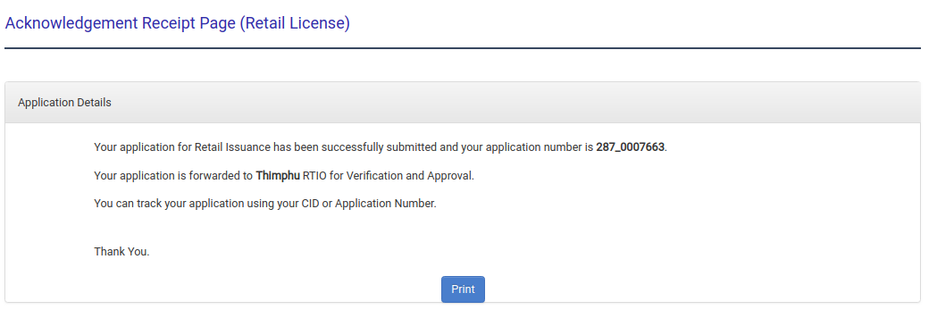

2.2.9 Verification of Retail Trade Registration by Data manager.
2.2.9.1 Description
This use case will describe how the application for Retail trade registration is being verified by data managers. The data manager need to log in to the system and needs to pick application for retail trade from group task to proceed with verification. He/she can also release application back to group task so that the application will be visible to other with same role, if he/she cannot take action. Clicking on application id from my task list, application will open and all details will be displayed for verification. Now he/she may verify or reject the application according to the application requirement.
2.2.9.2 Actor(s)
Data managers from RTIO.
2.2.9.3 Detailed process flow
- DM can visit to G2C portal and login with his/her valid user credentials.
- Task list will be displayed and Application For Retail Trade Registration will be listed in either group task list if that application is not yet claimed by any one with same role or in my task list if that application was already claimed and not taken any action.
- If application is in group task list, then he/she needs to claim that application to my task list and take action. Then he/she needs to open the application.
- After reviewing the application details, he/she need to take action(verify/reject) or assign back to group task list if he/she can’t take any action.
- DM will either verify or rejects the application. If application is rejected, then applicant will receive notification with reason for rejecting and if the application is verified then the same application will be reached to Director’s task list of RTIO.
- DM will be redirected to the acknowledgement page for respective actions.

2.2.9.4 Alternative Flows (if any)
NA.

2.2.9.5 Special requirement (if any)
NA.

2.2.9.6 Pre Conditions
Following are the pre- conditions to use the service –
- Internet access at RTIO.
- Should have valid login credentials.

2.2.9.7 Post Conditions
Applicant will receive sms notification for taking any action by TRMD and Director’s task list will be populated with verified applications.

2.2.9.8 Sample user interface
- Open www.citizenservices.gov.bt and click on log in as shown below and provide valid user credentials(username and password).

- He/she will be redirected to the dash board containing application list according to the role as shown below.

- Click on application number in group task list to claim to my task list. From my task list, again click on application number to open application. Click on red cross button form my task list to release application back to group task.

- Review and verify application details.

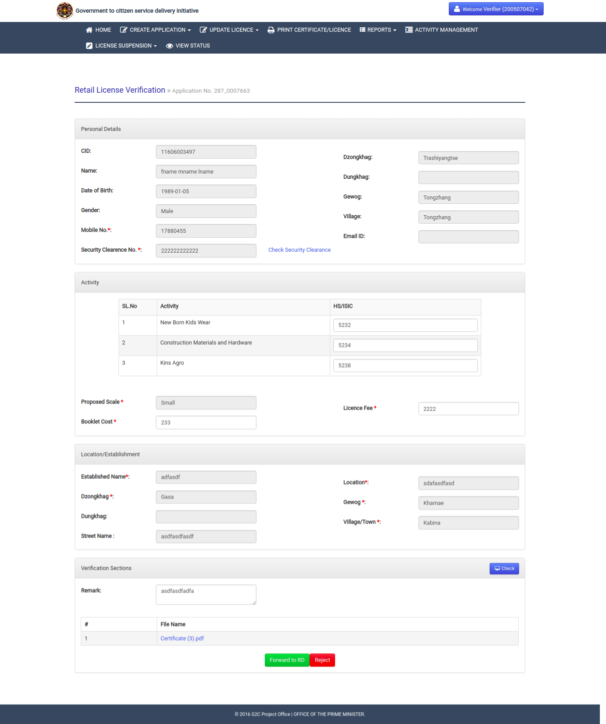

- After verification of the application details, he/she may need to take any of the action Forward to RD or reject. He/she needs to provide reason if application need to reject and need to mention fees details for service if verify. Then, he/she will be redirected to the acknowledgement page with the sms notification to applicant.

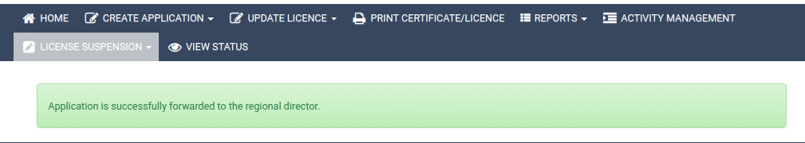

2.2.10 approval of Retail Trade Registration by Director.
2.2.10.1 Description
This use case will describe how the application for Retail trade registration is being approved by director from RTIO. The director need to log in to the system and needs to pick application for retail trade from group task to proceed with verification. He/she can also release application back to group task so that the application will be visible to other with same role, if he/she cannot take action. Clicking on application id from my task list, application will open and all details will be displayed for approval. Now he/she may approve or reject the application according to the application requirement.
2.2.10.2 Actor(s)
Director from RTIO.
2.2.10.3 Detailed process flow
- Director can visit to G2C portal and login with his/her valid user credentials.
- Task list will be displayed and Application For Retail Trade Registration will be listed in either group task list if that application is not yet claimed by any one with same role or in my task list if that application was already claimed and not taken any action.
- If application is in group task list, then he/she needs to claim that application to my task list and take action. Then he/she needs to open the application.
- After reviewing the application details, he/she need to take action(approve/reject) or assign back to group task list if he/she can’t take any action.
- Director will either approve or rejects the application. If application is rejected, then applicant will receive notification with reason for rejecting and if the application is approved then the same application will be reached to print list.
- Director will be redirected to the acknowledgement page for respective actions.

2.2.10.4 Alternative Flows (if any)
NA.

2.2.10.5 Special requirement (if any)
NA.

2.2.10.6 Pre Conditions
Following are the pre- conditions to use the service –
- Internet access at RTIO.
- Should have valid login credentials.

2.2.10.7 Post Conditions
Applicant will receive sms notification for taking any action by Director.

2.2.10.8 Sample user interface
- Open www.citizenservices.gov.bt and click on log in as shown below and provide valid user credentials(username and password).

- He/she will be redirected to the dash board containing application list according to the role as shown below.

- Click on application number in group task list to claim to my task list. From my task list, again click on application number to open application. Click on red cross button form my task list to release application back to group task.

- Review and verify application details.

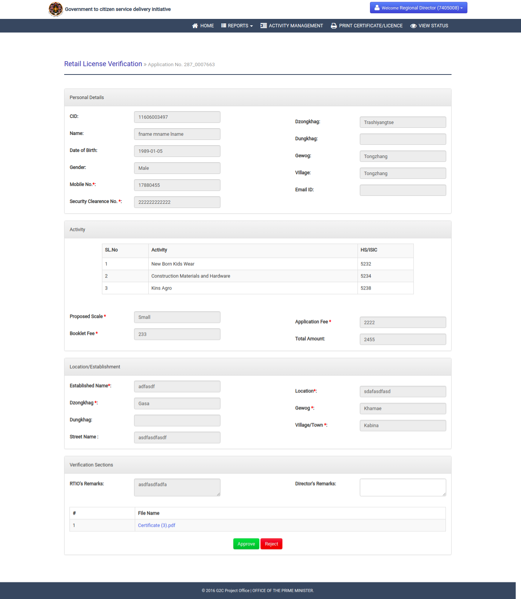

- After verification of the application details, he/she may need to take any of the action approve or reject. He/she needs to provide reason if application need to reject. Then, he/she will be redirected to the respective acknowledgement page for taking action and sms notification will be send to applicant.
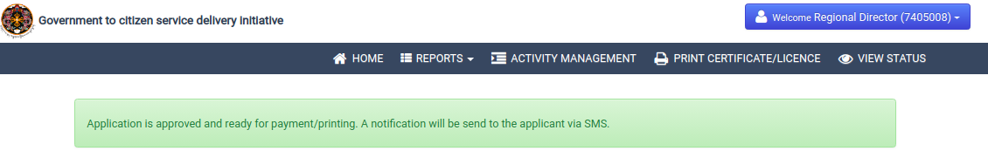

2.2.11 Payment, Printing and Distributing of Retail Wholesale Trade License.
2.211.1 Description
This use case will describe how the wholesale trade registration will be printed and distributed to applicant from RTIO after making payment for availing service. The data manager form RTIO need to log in to the system to update payment and print the certificate. Applicant can make payment in two ways, either pay online or pay at rtio(offline). If applicant update payment online, then he/she need to visit G2C portal for payment with application id or same link can be open form sms notification. If applicant make payment at RTIO, then data manager will update the payment details in the system. Data manager need to visit the link called Print certificate from menu and select update payment tab, select service name and region where the application belongs to and then need to provide payment details after opening the form. After updating the payment, application will be there in print list and data manager again need to visit same link from menu and select print certificate tab and print license.
2.2.11.2 Actor(s)
Data manager (Verifiers) from RTIO and applicant.
2.2.11.3 Detailed process flow
- Data manager can visit to G2C portal and login with his/her valid user credentials.
- Need to go with the link called print certificate/license from menu bar.
- To update the payment at RTIO, data manager needs to select the tab called Update payment, select the service as wholesale trade license and respective region form drop down list. And click on get details button.
- The list of approved application for wholesale trade registration will be displayed. He/she needs to select the application and click on update payment button to reach payment form.
- Provide payment details and press update button to record the payment details.
- The application status will be updated to approved will be there in print list.
- Data manager needs to click on same link called print certificate from menu and select print certificate tab, service as wholesale trade and region to list the application list to print.
- Now he/she may select application to print and distribute to applicant.

2.2.11.4 Alternative Flows (if any)
- The applicant can update payment online. To do that, applicant need to visit his sms to reach payment link directly to update payment.
- Applicant can also visit to G2C portal, and search for G2C payment link to update if he/she knows the application number.
- After providing valid and approved wholesale trade registration number, payment details will be displayed and need to clink on pay now button to update or make payment.
- The applicant will get interface to select available banks and OTP will send to registered mobile number for validation.
- Then the applicant will get payment receipt number and application status will be updated to print.

2.2.11.5 Special requirement (if any)
NA.

2.2.11.6 Pre Conditions
Following are the pre- conditions to use the service –
- Internet access at RTIO.
- Data manager should have valid login credentials.

2.2.11.7 Post Conditions
NA.

2.2.11.8 Sample user interface
- Open www.citizenservices.gov.bt and click on log in as shown below and provide valid user credentials(username and password).

- He/she will be redirected to the dash board containing application list according to the role as shown below.

- Click on the link called print certificate from menu bar.

- Data manager will be redirected to the following page where he/she need to select the update payment tab, service as wholesale License and region where applicant belongs to update payment.

- After clicking on the get list button, all the approved micro trade registration certificate will be displayed as shown below.

- After selecting the application, click on payment button to display form for payment update as shown below.

- After updating the payment, the application will be there in the print list and need to click on same link called print certificate from menu bar.

- Data manager will be redirected to the following page where he/she need to select the print certificate tab, service as wholesale trade and region where applicant belongs to.

- After clicking on the get list button, all the approved micro trade registration certificate will be displayed as shown below.

- Now data manager will click on print button to print certificate and distribute to applicant.Following image represent the license printed content from the system.
